**Yogashree MD**

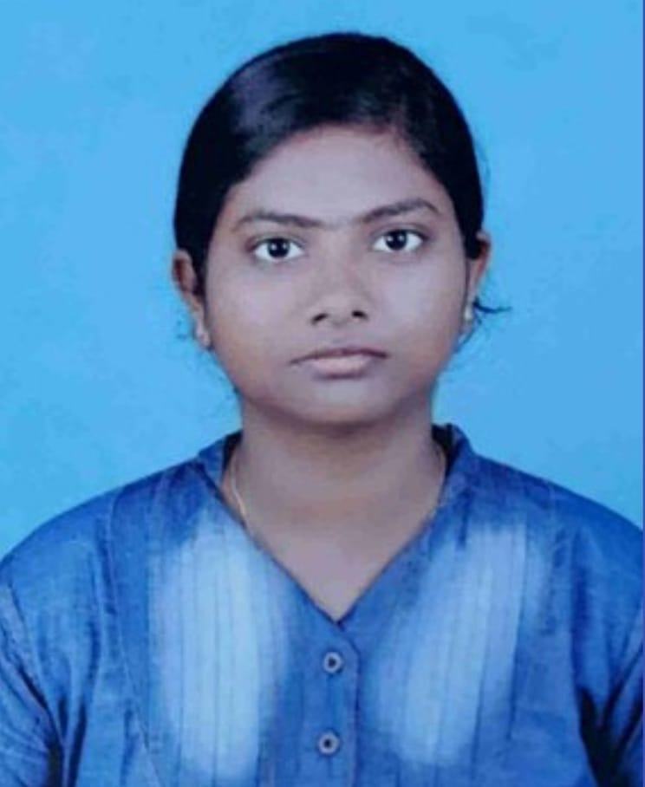

25/3 cavery nagar,nawab garden,

2nd cross woraiyur,Trichy-620003

**Mail :** yogashree2409@gmail.com

**Mobile :** +91-8838687376

**Objective:**

Looking for an opportunity to work as a professional engineer in a well established organization where my management skills, hard work combined with smartness is utilized.

**Academics:**

|  |  |  |  |  |
| --- | --- | --- | --- | --- |
| **Course** | **Institution** | **Board/**  **University** | **Year of passing** | **Percentage/**  **CGPA** |
| B.E.  (ECE) | K. Ramakrishnan college of Engineering , Trichy | Annauniversity | Pursuing | 8.815* |
| Higher secondary(+2) | Kamala Niketan Montessori School | CBSE | 2019 | 57% |
| SSLC | Mahatma Gandhi Centunary Vidayalaya | CBSE | 2017 | 8.8cgpa(88%) |

(* upto 4th semester)

**Software skills:**

* C++
* Python

**Interpersonal Skills:**

* Team work ,patience and positive motivator
* Work ethics: Time management,responsibility and discipline.

**Workshop:**

* Participated in four days hands on workshop on Design and Development of Programming controller for industrial application conducted by the department of Electronics And Communication Engineering of K.Ramakrishanan College of Engineering ,trichy on 16/03/2021 to 19/03/2021.
* Member of IEEE

**Paper Presented:**

* **Presented a paper on “Stagnation free road” in an intra college event held at K.Ramakrishnan College of Engineering on 12/09/2020.**

**Project:**

* **Done a mini project on “Plant moisture detector” in an project expo held at K.Ramakrishnan College of Engineering on 17/03/2021.**

**Personal Details:**

* DOB : 24/09/2001
* Father’s name : Mohan.P
* Nationality : Indian
* Hobbies : Craft making, Painting
* Languages known : Tamil,English,Telugu

DECLARATION

I hereby declare that all above information is true to the best of any knowledge.

**Place:** Trichy

**(YOGASHREE MD)**